LCC TOOL
USER’S MANUAL

- INTRODUCTION
Within task 2.2 of H2020 CRAVEzero project, a Life-Cycle Cost (LCC) spreadsheet was prepared in order to collect cost data from the investigated case studies. The CRAVEzero spreadsheet was then improved with the objective to develop a comprehensive tool to perform life-cycle cost analysis for nZEBs.
This guideline aims at providing a general overview of the LCC tool and its features, explaining the main sections and highlighting the input data.

  - NORMS AND STANDARDS
The data collection, within the tool, is organized following as a base reference the LCC structure introduced by the Standard ISO 15686-5:2017 (Buildings and constructed assets -- Service life planning -- Part 5: Life-cycle costing). Furthermore, the source used to structure the construction costs is the European Code of Measurement, elaborated by the European Committee of the Construction Economists.
Regarding the analysis of maintenance costs of HVAC systems, this is based on standard values from EN 15459:2018, which provides yearly maintenance costs for each element, including operation, repair, and service, as a percentage of the initial construction cost. Lifespan for system replacement is also provided by the norm.
Table 1: Cost structure according to ISO 15686-5:2017
 |  | Life cycle processes | LCC tool
Whole life cost |  | 1. Political decision and urban design phase | Non-construction costs
 | Life-cycle cost | 2. Building design phase | Design costs
 |  | 3. Construction phase | Construction costs
 |  | 4. Operation phase | Energy costs
 |  | 5. Renovation phase | Maintenance costs
 |  | 6. Recycling, dismantling and reuse phase | Not implemented
The ISO 15686-5:2017 groups the costs as indicated in Table 1: the LCC analysis includes the processes from point 2 to 5, and it deals with the activities connected with the design, construction and operation of the building. End-of-life costs (process 6 in the table) have not been implemented in the tool yet.
The Whole Life Cost (WLC) includes also the process 1, with the non-construction cost (e.g. cost of land, enabling activities) and the needed fees for allowing the set-up of the building from the technical and administrative point of view.

- GENERAL DESCRIPTION OF LCC TOOL SECTIONS
The LCC tool is composed by 6 sheets “Project information”, “WLC”, “Construction cost”, “Calc maintenance”, “Results” and “Charts. The first 4 sheets are devoted to receive input values, the last 2 display the results of the calculation. Three different types of cells are present, as reported in Figure 1.
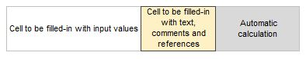
Figure 1: LCC tool cell types.

  - PROJECT INFORMATION
In this first input sheet general data about the analyzed building is collected, together with those boundary conditions needed for the LCC calculation.
In the first section data about surfaces and volumes need to be provided (Figure 2). The possibility to insert variants through the buttons displayed in Figure 2, will be discussed later.
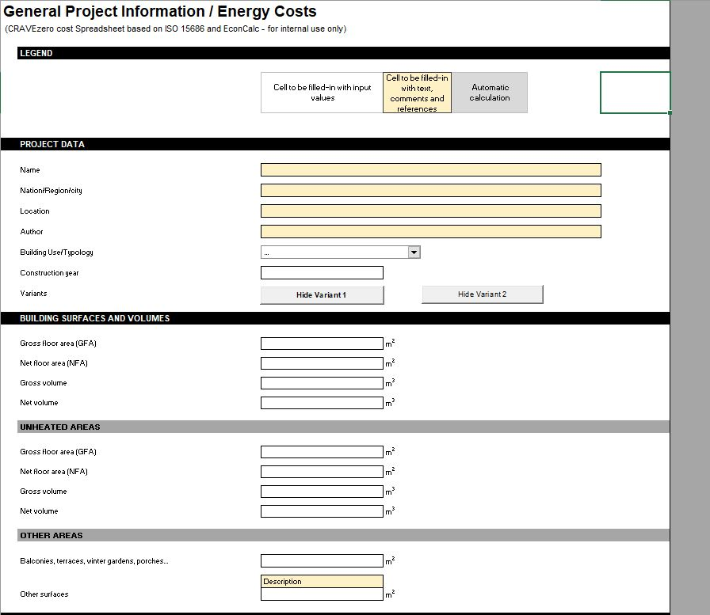
Figure 2: Project information – Project and geometrical data.
Following, data from the energy calculation is required (Figure 3). First, a reference area must be provided. The definition of “Treated floor area” comes from PHPP, the energy calculation tool used during the data collection campaign. If another tool is used for the energy calculation, the net floor area should be provided instead.
The input parameters from “Average U-value opaque components” to “ PV installed capacity” are not essential for the LCC calculation, since they are used to calculate indicators.
A section, which provides a check on the building construction costs, was also integrated to support the data collection. In this way it is possible to verify the correctness of data inserted in the “Construction cost” sheet comparing the sum of those values with the total cost (design + construction) inserted manually (if already available from a separate calculation).
Reference area
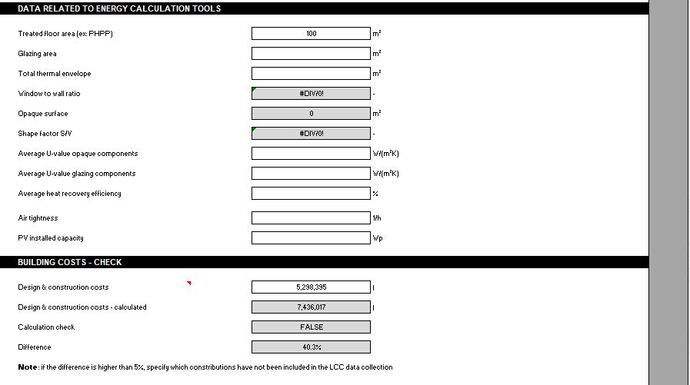
Figure 3: Project information – Data from energy calculation tool and check on building costs.

The following section (Figure 4) collects data about incomes. “Income” refers to the revenues obtained during the building operation. In particular, data about monthly rent, rented area, taxes can be provided, but, if other sources of revenues are available, please insert them in “Other Income”. The possibility to insert the income generated by selling the building was also included in the cell “expected building price”.
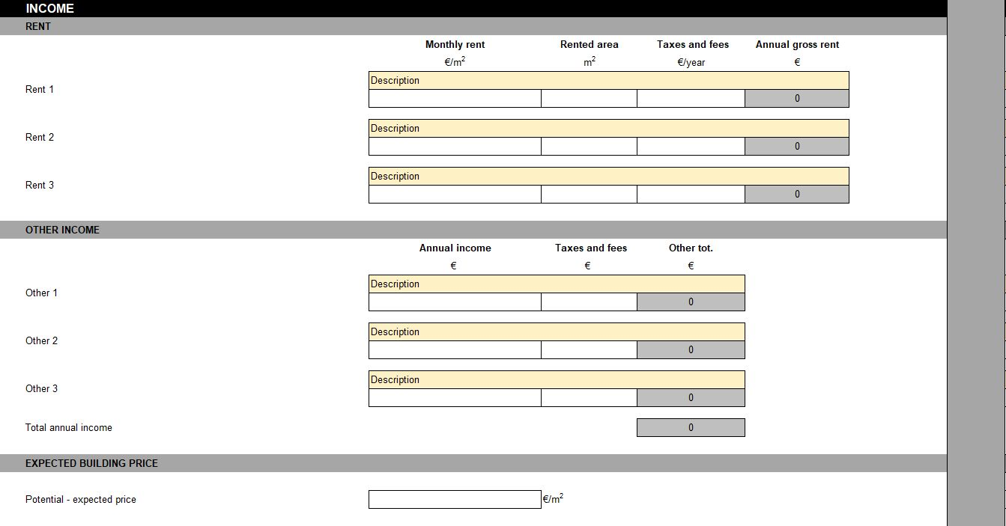
Figure 4: Project information – Income data.
Economic boundary conditions are collected in this section (Figure 5). This permits the calculation of actualized energy and maintenance costs over the building life span. Essential for the calculation are interest rate, the fuel prices and their average annual price increase.
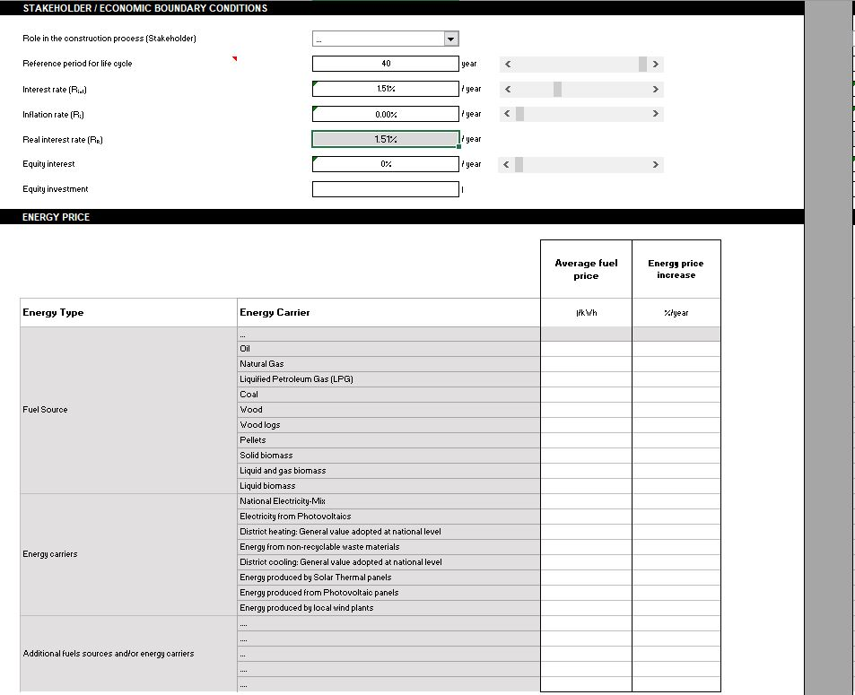
Figure 5: Project information – Boundary conditions and energy vectors prices.

Finally, data about energy consumption (kWh/m²) and production in (kWh) must be provided (Figure 6), in order to determine operational cost.
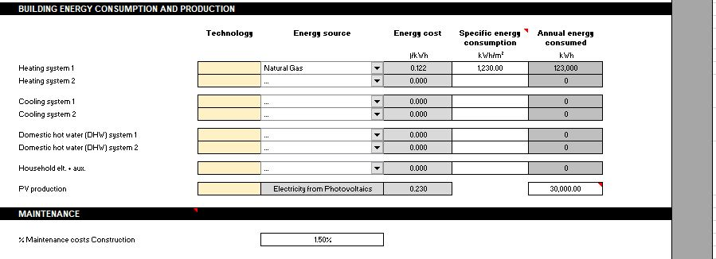
Figure 6: Project information – Building energy consumption/production and maintenance.

Variants can be investigated. Two buttons, also present in the other sheets, permit to display up to 2 variants (Figure 7). In this way different input values can be compared.

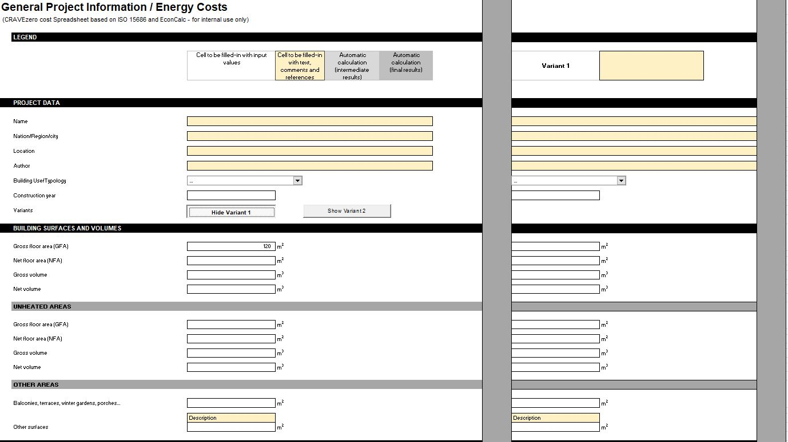
Figure 7: Project information – Display of variants.

  - WHOLE LIFE COST (WLC)
In this sheet non-construction cost and costs related to building design process are collected. This data, together with the construction cost collected in the next sheet “Construction cost” and the calculated O&M costs, build the WLC.
In the first section (Figure 8) non-construction costs such as cost of land, enabling costs and planning fees can be provided. Two columns are available to split the costs and to maintain a better overview, if required by the specific cost structure.
- Cost of lands: costs of land (and the volume allowed to be built).
- Price: unitary price of land.
- Enabling costs: cost for site preparation works that might take place prior to work under the main construction contract. This could include: demolition, site clearance, tree protection, diversion and / or disconnection of existing site services, geotechnical and exploratory ground investigation, decoupling from existing buildings, decontamination, ground improvement and /or compaction, excavation of known below-ground obstructions, survey work, creation of access routes, perimeter fencing and security provisions, work to neighboring buildings, discharging planning conditions that must be satisfied prior to construction commencing, historical architectural investigation fieldwork, access ramps, signage provisions, provision of statutory utilities to the site).
- Planning fees: taxes and fees to be paid for getting the permissions and fulfil the administrative issues
- User support costs: it includes all the cost for the support activities during the organization phase (management of the property, helpdesk and IT services, general administration issues).
- Finance Costs: costs related to the interest or costs of money (in case of bank loan).

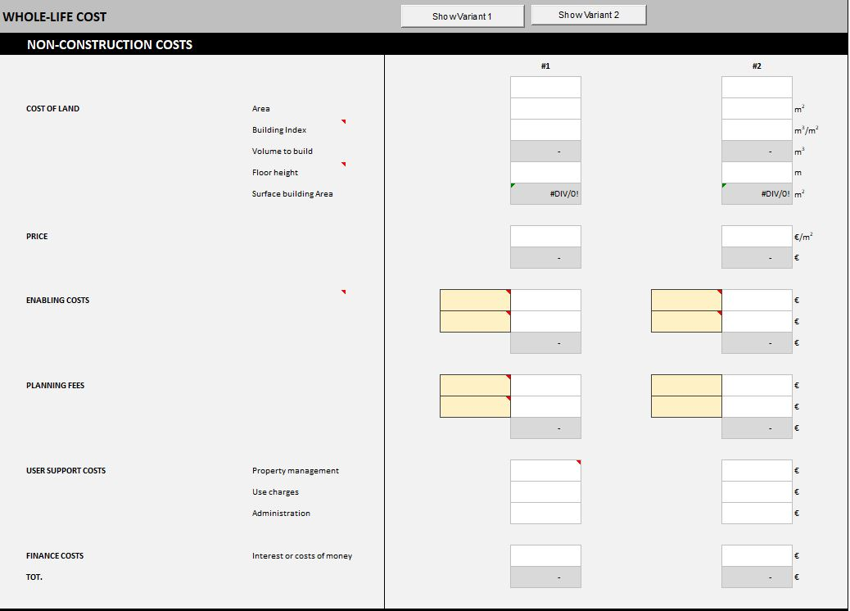
Figure 8: Whole life cost (WLC) – Non construction costs.
In the second section of the WLC sheet, design costs should be provided, divided in preliminary, definitive and executive design (Figure 9). Standard cost typologies are displayed, nevertheless if required, other costs can be added starting from line 27.
Building site management costs are also included in this sheet. These are costs for the general building site management, in terms of supervision of the activities, organization and cost for the general equipment (e.g. crane, scaffolding, etc.). Please, insert here the cost of the equipment when it deals with the general building site operation, while insert in the sheet “Construction cost”, in the cells related to “Other Costs” when it deals with a particular building element (e.g. use of a special crane for mounting a prefabricated element).
In the same way as in the previous sheet, also here it is possible to display up to 2 variants to be analyzed.
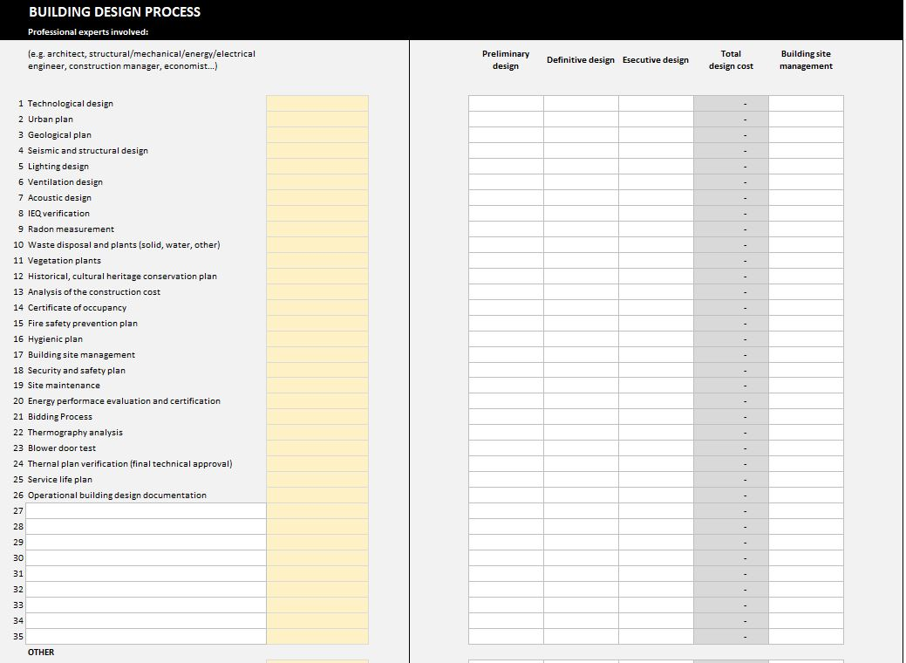
Figure 9: Whole life cost (WLC) – Building design process.

  - CONSTRUCTION COST
In this section a detailed breakdown of construction costs is required (Figure 10). On the left side a brief description of the single layer and the corresponding area can be inserted (arrow n.1). Cost of the materials, labor costs and other costs can be provide. In the case of material costs, either aggregated costs or unitary price can be provided (arrow n.2). If a breakdown of material and labor costs is not available, the global cost (construction cost) must be inserted in the yellow section “Materials”.

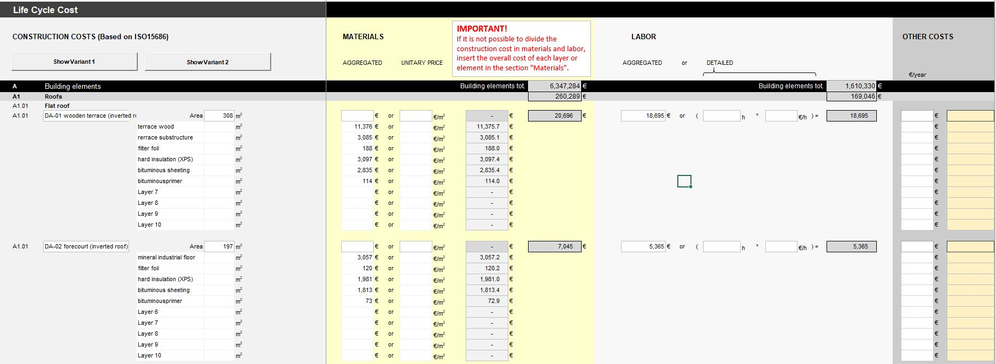
2
1
Figure 10: Construction cost input.

  - RESULTS
In this sheet the results of the LCC calculation are provided. The results have been divided summarizing building elements, building services, whole life costs, construction and operation.

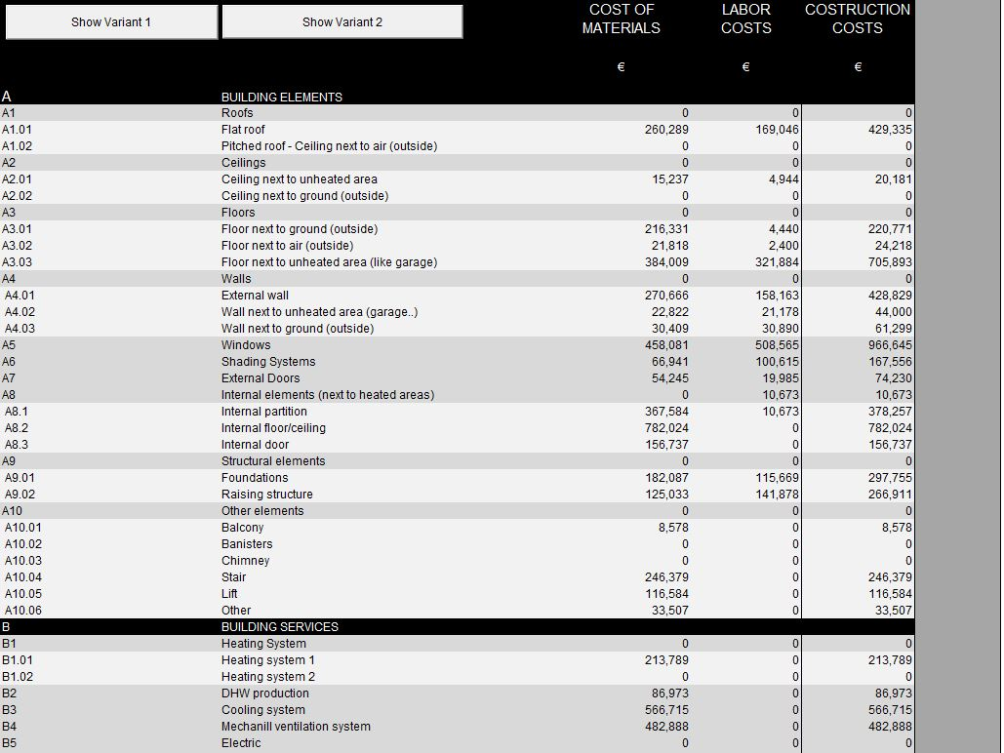
Figure 11: Results – Construction costs.
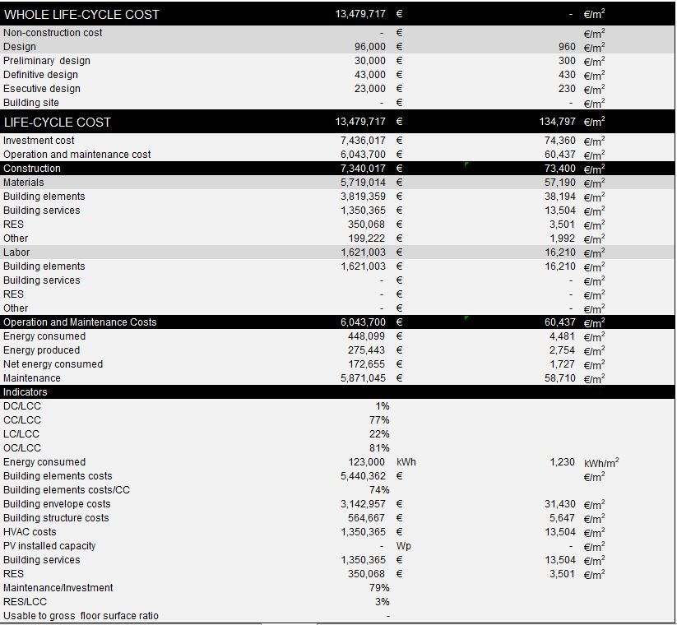
Figure 12: Results – WLC, LCC and indicators.

The following figure 13 display a detailed breakdown of the LCC costs.
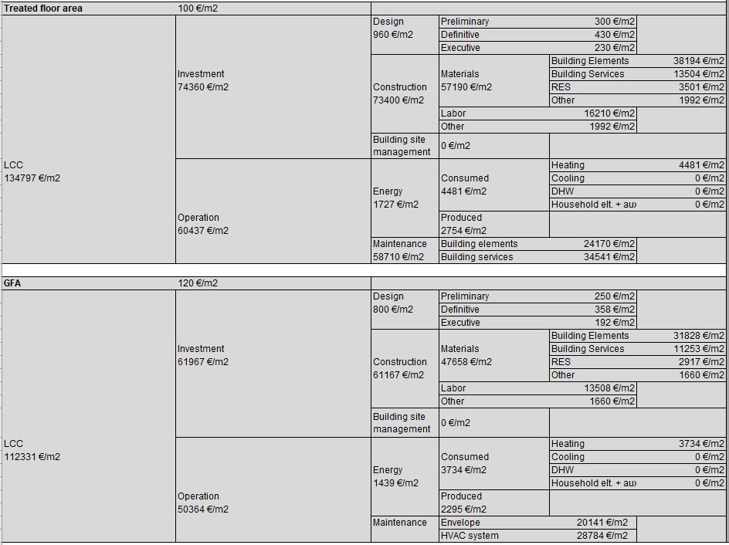
Figure 13: Results – LCC breakdown.
Finally, in the sheet “Charts” the numerical results are displayed in graphical way.
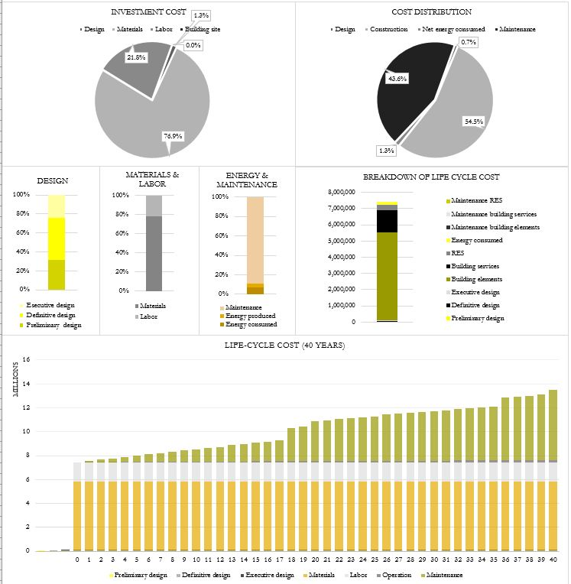
Figure 14: Charts.

LCC WEB TOOL
Getting Started
A simplified web version of the CRAVEzero LCC tool aims at providing an easy-to-use tool to perform preliminary LCC calculation, using aggregated input data.

Step 1 – General Information / Energy costs
Navigation bar – LCC tool
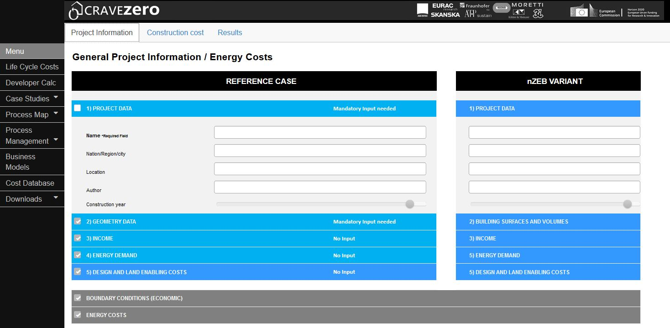
Possibility to analyze and compare a variant
Insert data about the geometry, income, energy demand, design, economic boundary conditions and energy vectors’ prices. One variant of the reference case can be investigated.

Step 2 – Construction costs

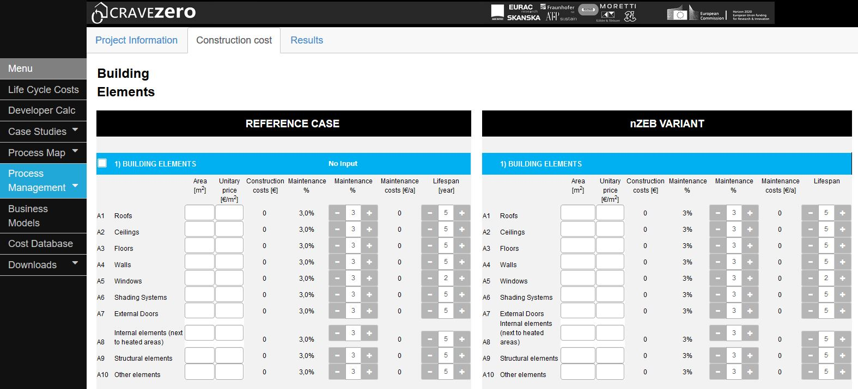
In this second sheet, aggregated data about construction costs for building elements and building services can be inserted. Maintenance cost as a percentage of the construction cost and the lifespan of the building element must be selected.

Step 3 – Results
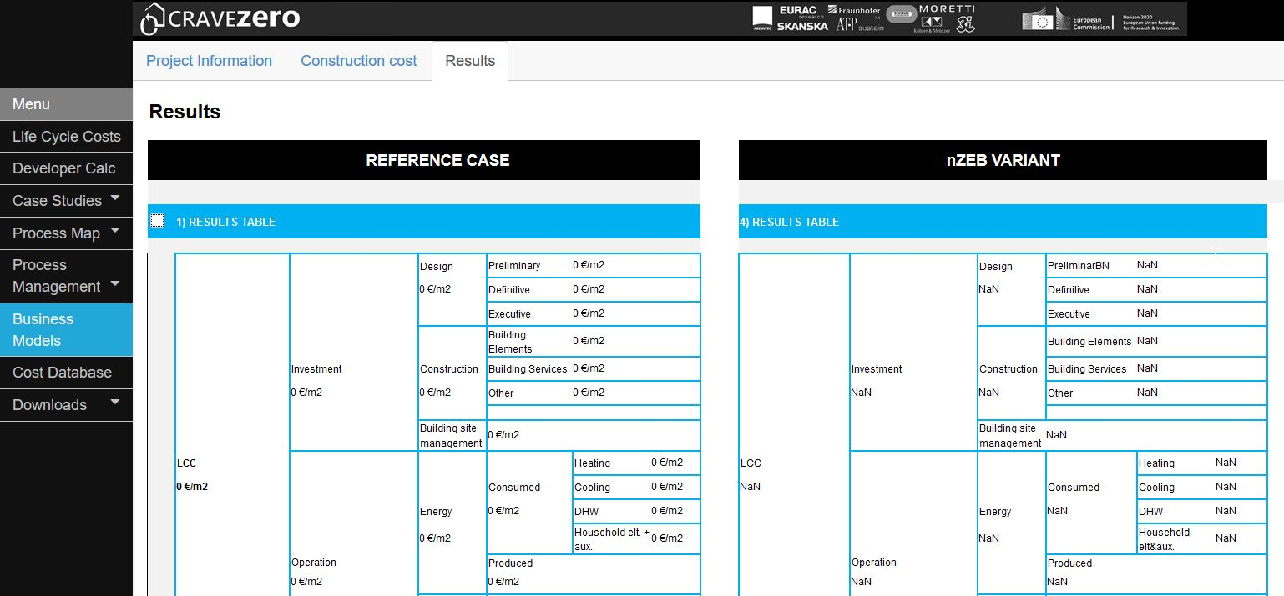
The last sheet displays the numerical breakdown of the LCC analysis, together with charts.

